“2.Spring REST Handson”
Hello World RESTful Web Service
1.HelloController.java
package com.cognizant.spring_learn.controller;
import org.slf4j.Logger;
import org.slf4j.LoggerFactory;
import org.springframework.web.bind.annotation.GetMapping;
import org.springframework.web.bind.annotation.RestController;
@RestController
public class HelloController {
private static final Logger LOGGER = LoggerFactory.getLogger(HelloController.class);
@GetMapping("/hello")
public String sayHello() {
LOGGER.info("START");
String message = "Hello World!!";
LOGGER.info("END");
return message;
}
}

2.SpringLearnApplication.java
package com.cognizant.spring_learn;
import org.slf4j.Logger;
import org.slf4j.LoggerFactory;
import org.springframework.boot.SpringApplication;
import org.springframework.boot.autoconfigure.SpringBootApplication;
@SpringBootApplication
public class SpringLearnApplication {
private static final Logger LOGGER = LoggerFactory.getLogger(SpringLearnApplication.class);
public static void main(String[] args) {
LOGGER.info("STARTING: SpringLearnApplication");
SpringApplication.run(SpringLearnApplication.class, args);
LOGGER.info("STOPPING: SpringLearnApplication");
}
}
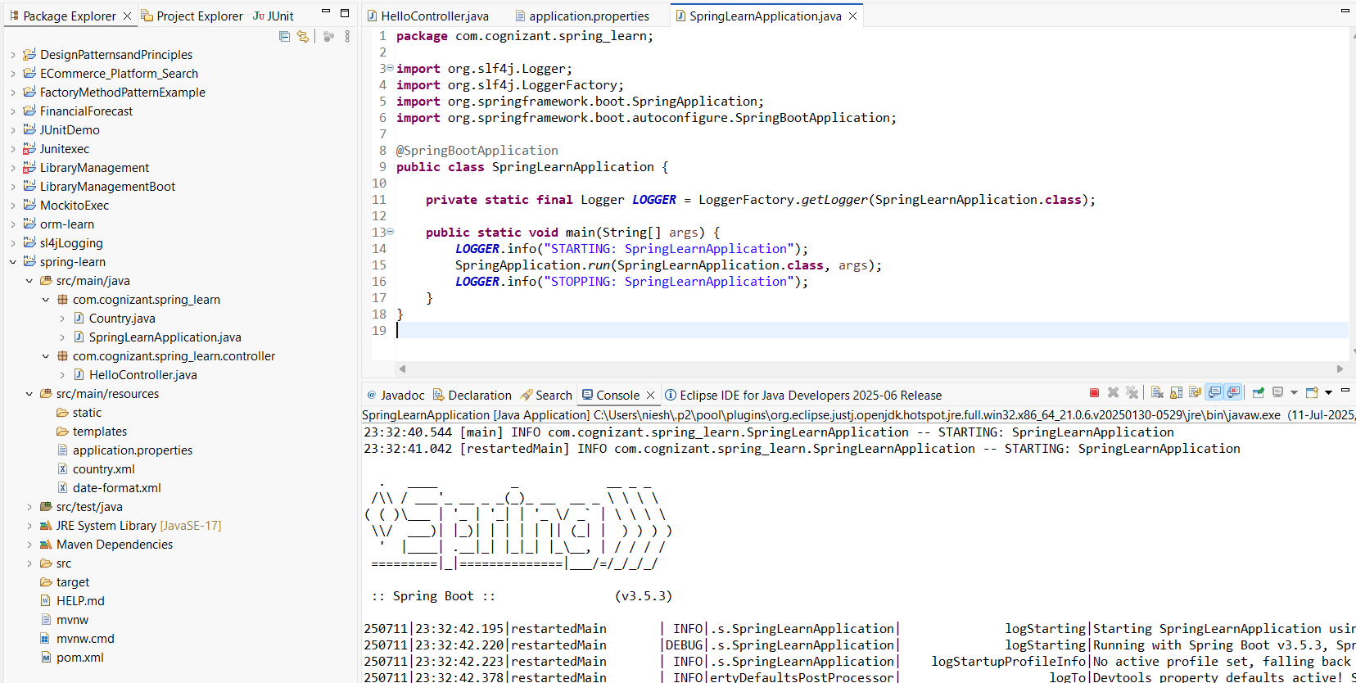
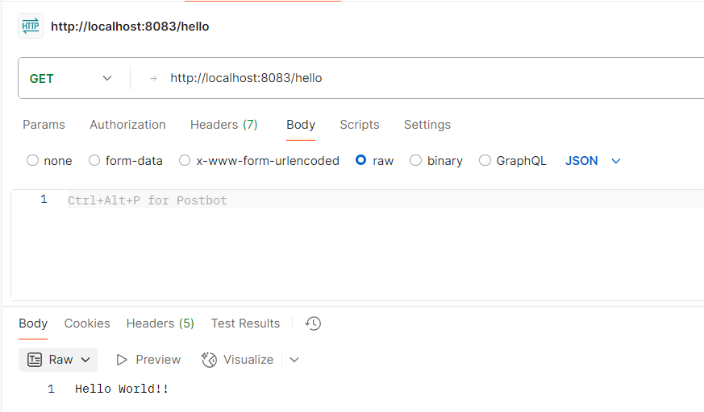
---------------------------------------------------------------------------------------------------------------------------

REST - Country Web Service
1.Country.java
package com.cognizant.spring_learn;
import org.slf4j.Logger;
import org.slf4j.LoggerFactory;
public class Country {
private static final Logger LOGGER = LoggerFactory.getLogger(Country.class);
private String code;
private String name;
public Country() {
LOGGER.debug("Inside Country Constructor.");
}
public String getCode() {
LOGGER.debug("Getting Country Code: {}", code);
return code;
}
public void setCode(String code) {
LOGGER.debug("Setting Country Code: {}", code);
this.code = code;
}
public String getName() {
LOGGER.debug("Getting Country Name: {}", name);
return name;
}
public void setName(String name) {
LOGGER.debug("Setting Country Name: {}", name);
this.name = name;
}
@Override
public String toString() {
return "Country [code=" + code + ", name=" + name + "]";
}
}
2.CountryController.java
package com.cognizant.spring_learn.controller;
import com.cognizant.spring_learn.Country;
import org.slf4j.Logger;
import org.slf4j.LoggerFactory;
import org.springframework.context.ApplicationContext;
import org.springframework.context.support.ClassPathXmlApplicationContext;
import org.springframework.web.bind.annotation.RequestMapping;
import org.springframework.web.bind.annotation.RestController;

@RestController
public class CountryController {
private static final Logger LOGGER = LoggerFactory.getLogger(CountryController.class);
@RequestMapping("/country")
public Country getCountryIndia() {
LOGGER.info("START");
ApplicationContext context = new ClassPathXmlApplicationContext("country.xml");
Country country = context.getBean("country", Country.class);
LOGGER.debug("Country : {}", country.toString());
LOGGER.info("END");
((ClassPathXmlApplicationContext) context).close();
return country;
}
}

3.SpringLearnApplication.java
package com.cognizant.spring_learn;
import org.slf4j.Logger;
import org.slf4j.LoggerFactory;
import org.springframework.boot.SpringApplication;
import org.springframework.boot.autoconfigure.SpringBootApplication;

@SpringBootApplication
public class SpringLearnApplication {
private static final Logger LOGGER = LoggerFactory.getLogger(SpringLearnApplication.class);
public static void main(String[] args) {
LOGGER.info("STARTING: SpringLearnApplication");
SpringApplication.run(SpringLearnApplication.class, args);
LOGGER.info("STOPPING: SpringLearnApplication");
}
}
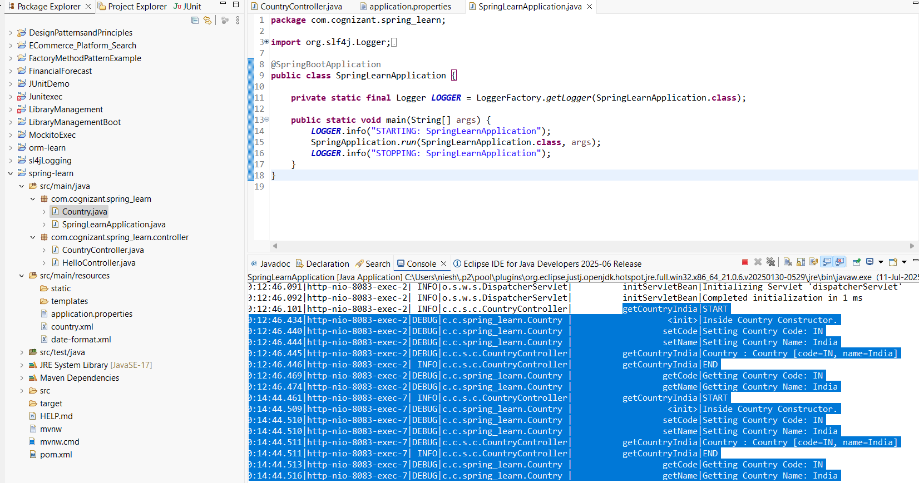

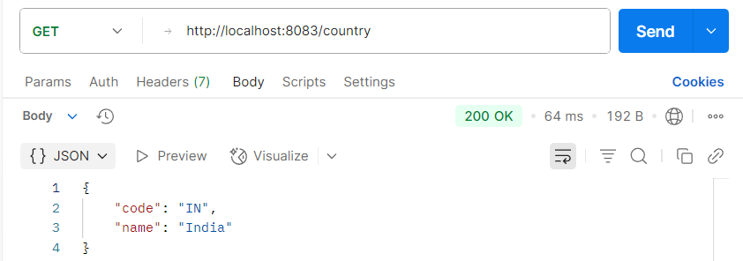
---------------------------------------------------------------------------------------------------------------------------
REST - Get all countries
1.SpringLearnApplication.java
package com.cognizant.spring_learn;
import org.slf4j.Logger;
import org.slf4j.LoggerFactory;
import org.springframework.boot.SpringApplication;
import org.springframework.boot.autoconfigure.SpringBootApplication;
@SpringBootApplication(scanBasePackages = "com.cognizant.spring_learn")
public class SpringLearnApplication {
private static final Logger LOGGER = LoggerFactory.getLogger(SpringLearnApplication.class);
public static void main(String[] args) {
LOGGER.info("STARTING: SpringLearnApplication");
SpringApplication.run(SpringLearnApplication.class, args);
LOGGER.info("STOPPING: SpringLearnApplication");
}
}
2.CountryController.java
package com.cognizant.spring_learn.controller;
import java.util.List;
import com.cognizant.spring_learn.Country;
import org.slf4j.Logger;
import org.slf4j.LoggerFactory;
import org.springframework.context.ApplicationContext;
import org.springframework.context.support.ClassPathXmlApplicationContext;
import org.springframework.web.bind.annotation.GetMapping;
import org.springframework.web.bind.annotation.RestController;
@RestController
public class CountryController {
private static final Logger LOGGER = LoggerFactory.getLogger(CountryController.class);
@GetMapping("/countries")
public List<Country> getAllCountries() {
LOGGER.info("START");
ApplicationContext context = new ClassPathXmlApplicationContext("country.xml");
List<Country> countries = context.getBean("countryList", List.class);
LOGGER.debug("Country List: {}", countries);
LOGGER.info("END");
((ClassPathXmlApplicationContext) context).close();
return countries;
}
}
3.Country.java
package com.cognizant.spring_learn;
import org.slf4j.Logger;
import org.slf4j.LoggerFactory;
public class Country {
private static final Logger LOGGER = LoggerFactory.getLogger(Country.class);
private String code;
private String name;
public Country() {
LOGGER.debug("Inside Country Constructor.");
}
public String getCode() {
LOGGER.debug("Getting code");
return code;
}
public void setCode(String code) {
LOGGER.debug("Setting code");
this.code = code;
}
public String getName() {
LOGGER.debug("Getting name");
return name;
}
public void setName(String name) {
LOGGER.debug("Setting name");
this.name = name;
}
@Override
public String toString() {
return "Country [code=" + code + ", name=" + name + "]";
}
}
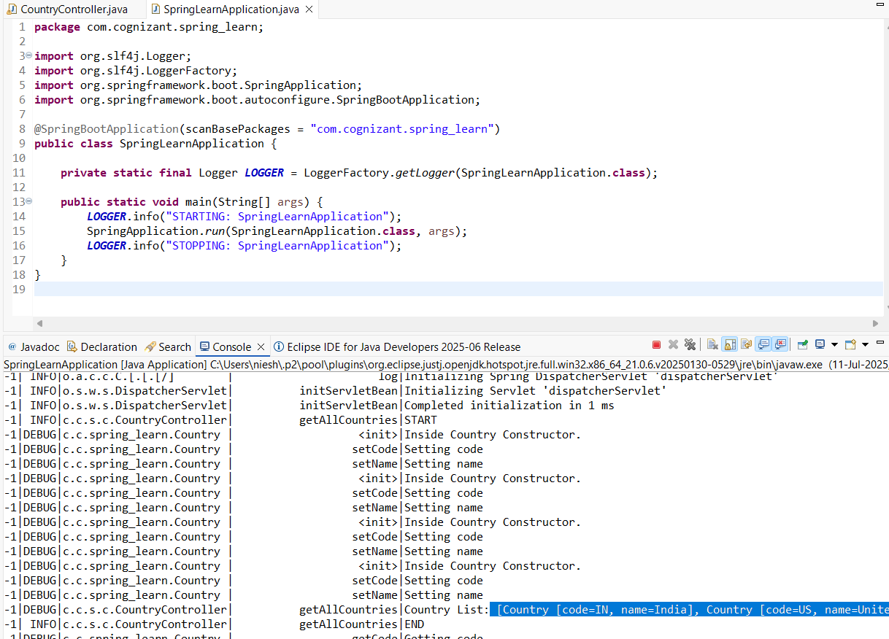
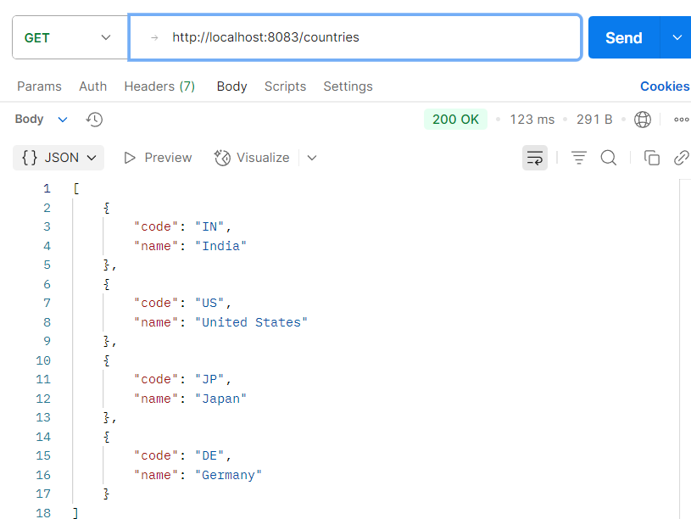
---------------------------------------------------------------------------------------------------------------------------
REST - Get country based on country code
1.Country.java
package com.cognizant.spring_learn.model;
import org.slf4j.Logger;
import org.slf4j.LoggerFactory;
public class Country {
private static final Logger LOGGER = LoggerFactory.getLogger(Country.class);
private String code;
private String name;
public Country() {
LOGGER.debug("Inside Country Constructor");
}
public String getCode() {
LOGGER.debug("getCode called");
return code;
}
public void setCode(String code) {
LOGGER.debug("setCode called with {}", code);
this.code = code;
}
public String getName() {
LOGGER.debug("getName called");
return name;
}
public void setName(String name) {
LOGGER.debug("setName called with {}", name);
this.name = name;
}
@Override
public String toString() {
return "Country [code=" + code + ", name=" + name + "]";
}
}
2.CountryService.java
package com.cognizant.spring_learn.service;
import com.cognizant.spring_learn.model.Country;
import org.slf4j.Logger;
import org.slf4j.LoggerFactory;
import org.springframework.context.ApplicationContext;
import org.springframework.context.support.ClassPathXmlApplicationContext;
import org.springframework.stereotype.Service;
import java.util.List;
@Service
public class CountryService {

private static final Logger LOGGER = LoggerFactory.getLogger(CountryService.class);

public Country getCountry(String code) {
LOGGER.info("START - getCountry Service: {}", code);

ApplicationContext context = new ClassPathXmlApplicationContext("country.xml");
List<Country> countryList = context.getBean("countryList", List.class);

Country country = countryList.stream()
.filter(c -> c.getCode().equalsIgnoreCase(code))
.findFirst()
.orElse(null);

((ClassPathXmlApplicationContext) context).close();
LOGGER.info("END - getCountry Service");
return country;
}
}
3.CountryController.java
package com.cognizant.spring_learn.controller;
import com.cognizant.spring_learn.model.Country;
import com.cognizant.spring_learn.service.CountryService;
import org.slf4j.Logger;
import org.slf4j.LoggerFactory;
import org.springframework.beans.factory.annotation.Autowired;
import org.springframework.web.bind.annotation.*;
@RestController
public class CountryController {
private static final Logger LOGGER = LoggerFactory.getLogger(CountryController.class);
@Autowired
private CountryService countryService;
@GetMapping("/countries/{code}")
public Country getCountry(@PathVariable String code) {
LOGGER.info("START - getCountry: {}", code);
Country country = countryService.getCountry(code);
LOGGER.info("END - getCountry");
return country;
}
}
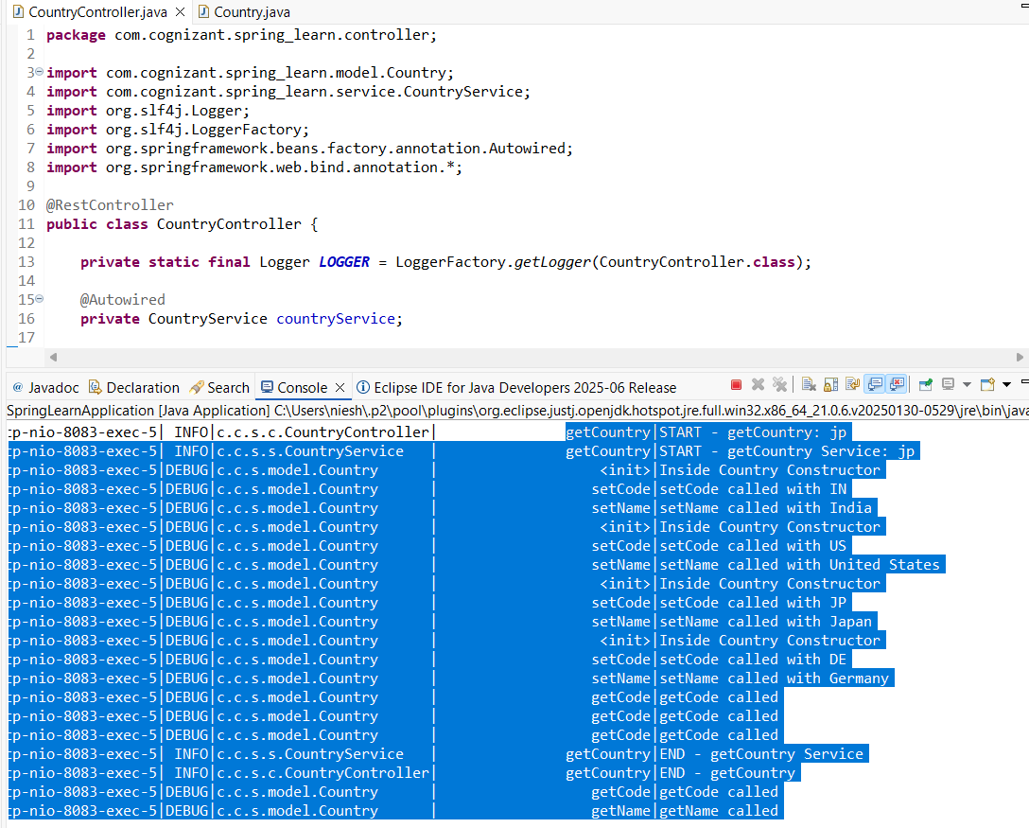
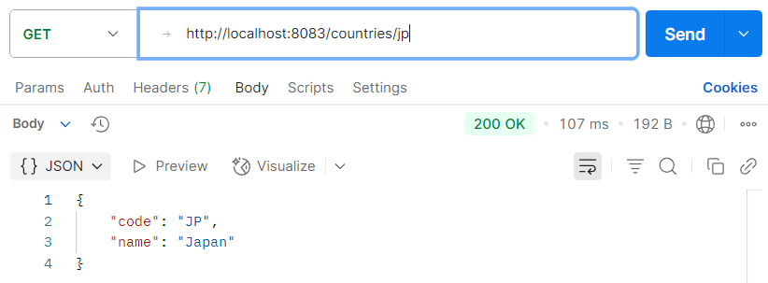
---------------------------------------------------------------------------------------------------------------------------
REST - Get country exceptional scenario
1.Country.java
package com.cognizant.spring_learn.model;
import org.slf4j.Logger;
import org.slf4j.LoggerFactory;
public class Country {
private static final Logger LOGGER = LoggerFactory.getLogger(Country.class);
private String code;
private String name;
public Country() {
LOGGER.debug("Inside Country Constructor");
}
public String getCode() {
LOGGER.debug("getCode called");
return code;
}
public void setCode(String code) {
LOGGER.debug("setCode called with {}", code);
this.code = code;
}
public String getName() {
LOGGER.debug("getName called");
return name;
}
public void setName(String name) {
LOGGER.debug("setName called with {}", name);
this.name = name;
}
@Override
public String toString() {
return "Country [code=" + code + ", name=" + name + "]";
}
}
2.CountryService.java
package com.cognizant.spring_learn.service;
import com.cognizant.spring_learn.model.Country;
import com.cognizant.spring_learn.service.exception.CountryNotFoundException;
import org.slf4j.Logger;
import org.slf4j.LoggerFactory;
import org.springframework.context.ApplicationContext;
import org.springframework.context.support.ClassPathXmlApplicationContext;
import org.springframework.stereotype.Service;
import java.util.List;
@Service
public class CountryService {
private static final Logger LOGGER = LoggerFactory.getLogger(CountryService.class);
public Country getCountry(String code) throws CountryNotFoundException {
LOGGER.info("START - getCountry Service: {}", code);

ApplicationContext context = new ClassPathXmlApplicationContext("country.xml");
List<Country> countryList = context.getBean("countryList", List.class);
Country country = countryList.stream()
.filter(c -> c.getCode().equalsIgnoreCase(code))
.findFirst()
.orElse(null);
((ClassPathXmlApplicationContext) context).close();
if (country == null) {
LOGGER.error("Country with code {} not found", code);
throw new CountryNotFoundException("Country with code " + code + " not found");
}
LOGGER.info("END - getCountry Service");
return country;
}
}
3.CountryNotFoundException.java
package com.cognizant.spring_learn.service.exception;
import org.springframework.http.HttpStatus;
import org.springframework.web.bind.annotation.ResponseStatus;

@ResponseStatus(value = HttpStatus.NOT_FOUND, reason = "Country not found")
public class CountryNotFoundException extends Exception {
public CountryNotFoundException(String message) {
super(message);
}
}
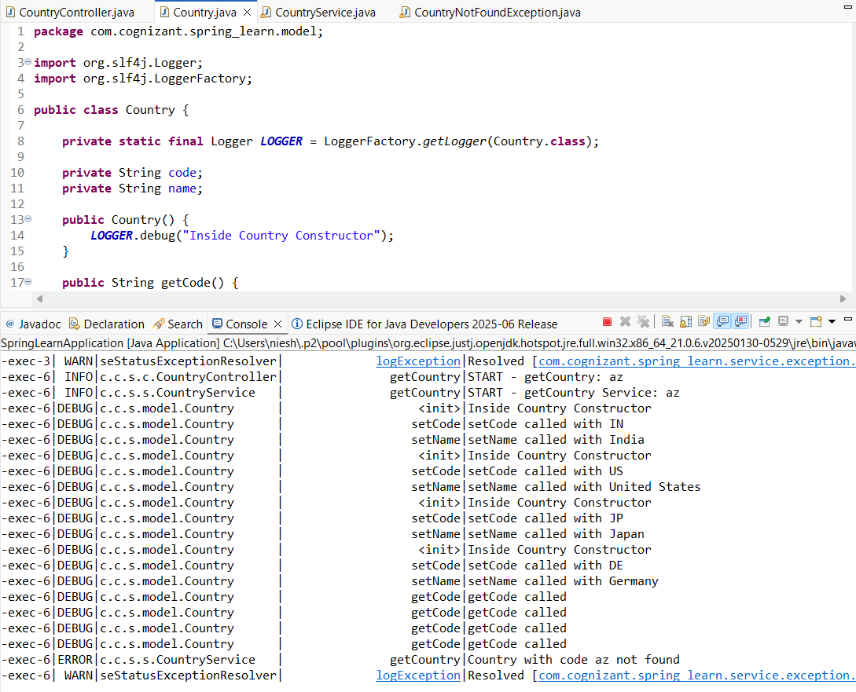

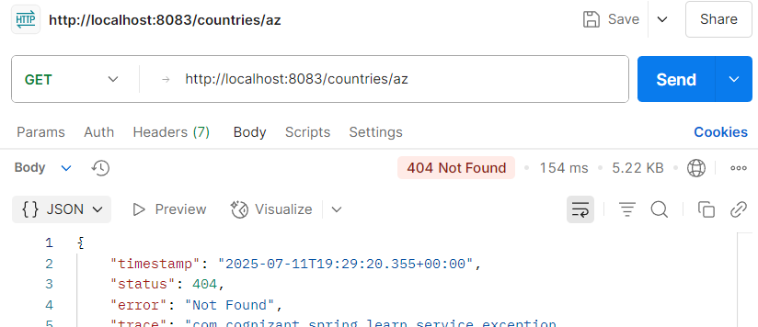
---------------------------------------------------------------------------------------------------------------------------
MockMVC - Test get country service
1.SpringLearnApplicationTests.java
package com.cognizant.spring_learn;
import com.cognizant.spring_learn.controller.CountryController;
import org.junit.jupiter.api.Test;
import static org.junit.jupiter.api.Assertions.assertNotNull;
import org.springframework.beans.factory.annotation.Autowired;
import org.springframework.boot.test.context.SpringBootTest;
import org.springframework.test.web.servlet.MockMvc;
import org.springframework.boot.test.autoconfigure.web.servlet.AutoConfigureMockMvc;
import org.springframework.test.web.servlet.ResultActions;
import static org.springframework.test.web.servlet.request.MockMvcRequestBuilders.get;
import static org.springframework.test.web.servlet.result.MockMvcResultMatchers.*;
@SpringBootTest
@AutoConfigureMockMvc
public class SpringLearnApplicationTests {
@Autowired
private CountryController countryController;
@Autowired
private MockMvc mockMvc;
@Test
public void contextLoads() {
assertNotNull(countryController);
}
@Test
public void testGetCountry() throws Exception {
ResultActions actions = mockMvc.perform(get("/country"));
actions.andExpect(status().isOk());
actions.andExpect(jsonPath("$.code").value("IN"));
actions.andExpect(jsonPath("$.name").value("India"));
} }



